# CS 255 System Design Document Template

Callie Oleson

6/18/2023

## UML Diagrams

### UML Use Case Diagram

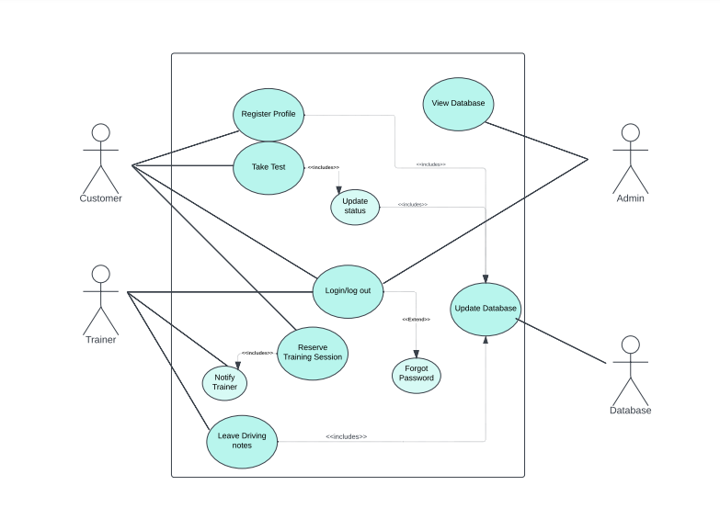

### UML Activity Diagrams

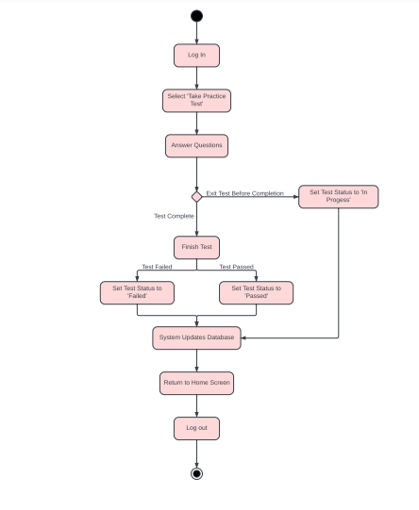

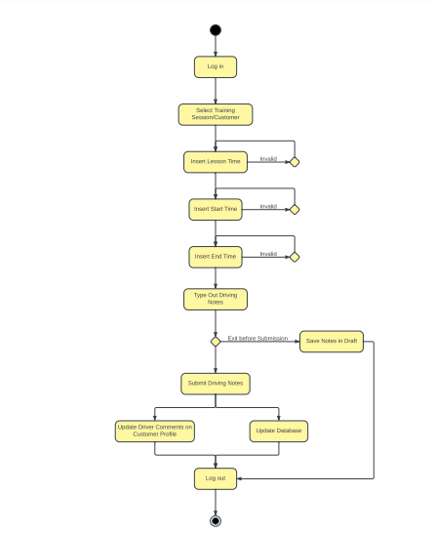

### UML Sequence Diagram

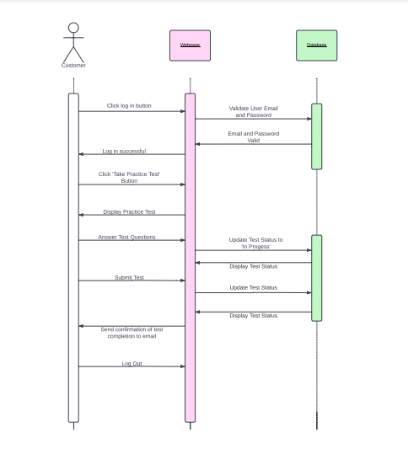

### UML Class Diagram

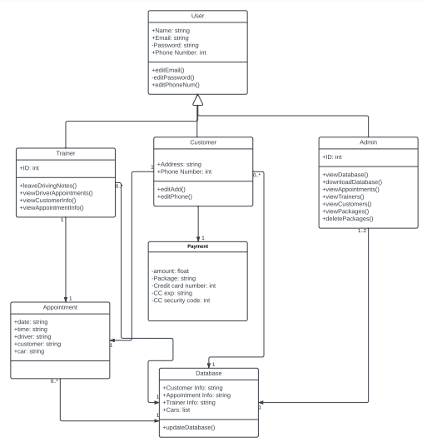

## Technical Requirements

* Authentication and authorization: email and password (case sensitive) required for access to all accounts.
* Must operate on all web browsers.
* Updates to the system should take less than a day to implement.
* Each webpage must take less than 5 seconds to load.
* Backend must have a database of all employee info, customer info, and appointments.
* Must run on the cloud.
* Must allow for 1,000 users at a time while maintaining performance.
* Human errors will result in a notification that warns the user of a discrepancy.
* System errors will result in an error screen for the user and a notification to the admin.
* The system will be updated with the current DMV policies and rules and sample questions.
* If a user forgets their password, they can have a reset password link sent to the email connected to their account.

**Sources**

*25 Examples of Technical Requirements*. (n.d.). Simplicable. https://simplicable.com/en/technical-requirements

*Multiplicity in UMLBoard*. (n.d.). Www.umlboard.com. https://www.umlboard.com/docs/relations/multiplicity/

Visual Paradigm. (2019). *What is Activity Diagram?* Visual-Paradigm.com. https://www.visual-paradigm.com/guide/uml-unified-modeling-language/what-is-activity-diagram/

‌*What are the six types of relationships in UML class diagrams?* (2022, February 9). Visual Paradigm Blog. https://blog.visual-paradigm.com/what-are-the-six-types-of-relationships-in-uml-class-diagrams/

‌